SIMATS ENGINEERING
Department of Information Technology
CSA15 – CLOUD COMPUTING AND BIG DATA ANALYTICS
ASSIGNMENT 2 – CO2
Analyse, Evaluate and Validate a Virtualization Architecture for a Multi-Tenant University Private Cloud CO2: Analyze virtualization architectures to identify performance and security issues in cloud computing environments.
Field | Details | Field | Details
Student Name | J.P.BADRI | Register Number | 192524301
Department / Section | B.TECH(AI&DS) | Academic Year / Semester | 2025-2029
Faculty Name | R.LATHA | Nature of Assignment | Individual
Duration | 1 Week | Total Marks | 50
Submission Date | 04/11/2026 | Evaluation Date
MARK SHEET (Rubric-based evaluation)
Task | Title | Max | Awarded | Evidence / evaluation focus
1 | Characterise the Virtualization Architectures | 5
2 | Identify the Dominant Overhead Source | 2

Task | Title | Max | Awarded | Evidence / evaluation focus
3 | Build a Quantitative Performance  Model | 6
4 | Analyse Performance Under Different Conditions | 4
5 | Security Threat and Vulnerability Analysis | 3
6 | Formulate Isolation–Performance Trade-off | 3
7 | Evaluate Mitigation Strategies | 4
8 | Implement and Test | 4
9 | Record Experimental Performance | 3
10 | Compare Theory with Experiment | 4
11 | Recommend and Defend Final Architecture | 4
 | Day-4 Design Challenge | 8

TOTAL
50
OVERALL REMARKS
Overall, the assignment reflects good analytical ability, technical understanding and problem-solving skills in cloud computing and virtualization. The proposed architecture balances performance, security, resource efficiency and future scalability. The work can be further strengthened through verified experimental results, consistent benchmark comparisons and practical validation of the recommended security controls.
Student Signature | Faculty Signature | Program Director
MANDATORY SUBMISSION EVIDENCE CHECK
= Present in documented answer; P = Partly present; X = Missing / not satisfied
Task | Evidence expected | Status | Evaluator note
1 | Three virtualization architectures, layered diagrams and trust boundaries
2 | Dominant overhead source identified and explained for each approach
3 | CPU, memory, I/O, network and density models with assumptions
4 | Best, typical and worst operating-condition analysis

Task | Evidence expected | Status | Evaluator note
5 | Threat model and architecture-based security comparison
6 | Isolation–performance optimization formulation
7 | Mitigation benefits, residual risks and quantified costs
8 | Reproducible setup and practical tests across selected platforms
9 | Actual comparative measurements, table and two graphs
10 | Theory–experiment comparison and quantitative error analysis
11 | Justified SIS/LMS architecture and growth recommendation
12 | Day-4 external tenants, 3× peaks, live migration and SIS isolation
IMPLEMENTATION EVIDENCE CHAIN
Evidence item | Status | Observation
Architecture diagrams
Performance model

Evidence item | Status | Observation
Configuration / scripts
Virtualization experiments
CPU / disk / network / memory tests
Noisy-neighbour experiment
Security validation
Tables and graphs
Theory–experiment consistency
Day-4 design defence
Screenshots
SUBMISSION CHECKLIST (Not Separately Marked)
Requirement | Status
All 12 tasks answered | Yes | Partly | No
Three virtualization approaches compared | Yes | Partly | No
Layered diagrams and trust boundaries included | Yes | Partly | No
Quantitative virtualization models included | Yes | Partly | No
Threat analysis and mitigations included | Yes | Partly | No

CLOUD COMPUTING AND BIG DATA
ASSIGNMENT 2
CO2: Analyze virtualization architectures to identify performance and security issues in cloud computing environments.
_________________________________________________________________

Assignment Title: Analyse, Evaluate and Validate a Virtualization Architecture

for a Multi-Tenant University Private Cloud (Total Marks: 50) Duration: 1 week
_________________________________________________________________

Scenario: EduCloud Virtualization Platform
A university runs a private cloud, EduCloud, in its data centre. EduCloud currently consists of:
- 16 physical hosts, each with 64 CPU cores, 512 GB RAM, NVMe SSD storage and 2 × 25 Gbps NICs
- About 400 virtual machines (VMs) running the Student Information System (SIS), the Learning Management System (LMS), the examination portal, and departmental research workloads
- A shared storage backend and a software-defined virtual network
During semester registration week, users report slow response times and failed logins. A recent internal security audit also found that VMs from different departments share the same physical hosts, that some VMs run outdated guest kernels, and that VM images are copied freely between teams.
You are the cloud architect. You must investigate, model, measure and compare virtualization architectures for EduCloud, identify their performance bottlenecks and security weaknesses, and recommend a design that remains practical as the platform grows.

Design Challenge:
The university now plans to host external research collaborators' big-data workloads (Spark/Hadoop clusters) on the same infrastructure as the SIS. Reevaluate your design under these new multi-tenant conditions.

TASK 1: Characterise the Virtualization Architectures (5 Marks)

Select at least three meaningfully different virtualization approaches from the following, or justify others:
- Type-1 (bare-metal) hypervisor with full virtualization
- Type-2 (hosted) hypervisor
- Hardware-assisted virtualization vs. paravirtualization
- OS-level virtualization (containers)
- Lightweight/micro-VM or sandboxed container runtimes
Two configurations of the same hypervisor will not count as different approaches. Your selection must include at least one VM-based and at least one container-based approach.
For each approach, provide:
- A layered architecture diagram showing the hardware, host OS or hypervisor, guest OS, runtime and application
- The trust boundaries and the component that enforces isolation
- How CPU, memory, storage and network are virtualized
- A brief justification for why this approach is relevant to EduCloud
Evidence expected: Three architecturally distinct approaches with labelled diagrams, resource-virtualization mechanisms, trust boundaries, and justification of selection.

TASK 2: Identify the Dominant Overhead Source (2 Marks)
For each approach, identify the primary source of performance overhead that predominantly limits its performance (for example VM exits/traps, nested or extended page-table walks, virtual I/O emulation, virtual switch processing, or system-call interception).
Discuss:
- What the overhead source is
- Where in the architecture it occurs
- Why it is appropriate as the focus of performance analysis
- How its frequency or cost changes as the number of co-located VMs/containers or the I/O rate increases
Do not simply name a mechanism. Relate it to the behaviour of the architecture.
Evidence expected: A justified dominant-overhead identification for each approach, linked to its resource-virtualization path.

TASK 3: Build a Quantitative Performance Model (6 Marks)
Using the following host parameters, develop an analytical performance model for each approach.
Parameter | Value
Physical cores per host | 64
vCPU:pCPU overcommit ratio | 1:1 , 2:1, 4:1, 8:1
RAM per host | 512 GB
Average VM memory demand | 8 GB
Cost of one VM exit (assume) | 1.5 µs
Native system-call cost (assume) | 0.2 µs
Network line rate | 25 Gbps

State and justify any additional assumptions. Derive expressions for:
- CPU: effective per-VM CPU capacity as a function of overcommit ratio and virtualization overhead (including steal time)
- Memory: the maximum number of VMs per host before ballooning, swapping or page-sharing becomes necessary
- I/O and network: effective throughput as a function of the number of VMs sharing the physical device
- Density: the number of VMs/containers a host can support while meeting a stated service-level target (for example, ≤ 10% performance degradation)
Show the mathematical reasoning. Merely quoting overhead percentages from the literature will not receive full credit.
Evidence expected: A clear mathematical derivation for each approach, with stated assumptions, parameter values and worked numerical examples.

TASK 4: Analyse Performance Under Different Operating Conditions (4 Marks)
Analyse how each approach behaves under three conditions:
- Best case: what workload and placement conditions minimise overhead?
- Typical case: for example, registration-week mixed web and database load
- Worst case: for example, noisy-neighbour interference, memory overcommit with swapping, live migration during peak load, or I/O storms
For each, explain what happens inside the virtualization layer, why the overhead changes, and how latency and throughput are affected. A table of numbers alone will not be accepted.
Evidence expected: A justified condition-based analysis supported by your Task 3 model.

TASK 5: Security Threat and Vulnerability Analysis (3 Marks)
Construct a threat model for each approach. Discuss:
- The attack surface (hypervisor, device emulation, shared kernel, management plane, VM images and snapshots, virtual network)
- At least four distinct threat categories, such as VM escape, cross-VM side-channel attacks, hypervisor or container-runtime vulnerabilities, VM sprawl and unpatched guests, image tampering, insecure live migration, and virtual-network sniffing or spoofing
- For each threat, which approach is more or less exposed and why, referring to its architecture and trust boundaries
- The likely impact on the confidentiality, integrity and availability of student records
Evidence expected: A structured threat model mapped to architectural features, with a justified comparison across approaches.

TASK 6: Formulate the Isolation–Performance Trade-off (3 Marks)
Formalise the trade-off between isolation strength and performance/density for EduCloud.
Clearly identify:
- The decision variables (for example, approach chosen, VMs per host, dedicated vs. shared hosts, SMT on/off)
- The objective(s), such as maximising density or minimising cost
- The constraints (for example, performance degradation limit, isolation requirement for SIS, available hosts)
- How these components combine into a cost or decision function
The formulation must follow from your own analysis in Tasks 3 and 5, not from a generic template.
Evidence expected: A clearly defined trade-off model with identified variables, objective and constraints.

TASK 7: Evaluate Mitigation Strategies (4 Marks)
Propose at least three mitigations for the vulnerabilities identified in Task 5. Examples include disabling SMT, kernel page-table isolation, dedicated hosts for sensitive tenants, secure or sandboxed container runtimes, hardware memory encryption, image signing, and micro-segmentation.
For each mitigation, discuss:
- Why it is applicable to the threat
- What residual risk remains
- The performance or density cost, estimated using your Task 3 model
- Whether the trade-off is acceptable for the SIS
Evidence expected: Mitigations evaluated analytically, with their security benefit and quantified performance cost.

TASK 8: Implement and Test (4 Marks)
Build a test environment and experimentally test all selected approaches.
- Platforms: use any open-source stack, for example KVM/QEMU, Xen or VirtualBox, Docker/Podman, and Kata Containers or gVisor. Nested virtualization on a laptop is acceptable if documented.
- Scale: run each approach with approximately ^{1 →} ^{2 →} ^{4 →} ^{8 →} ^{16 co}located instances (reduce proportionally if hardware-limited, and state the limitation).
- Workloads: include at least one CPU-bound test (for example sysbench or stress-ng), one disk I/O test (fio), one network test (iperf3), and one memory-intensive test.
- Interference test: run at least one noisy-neighbour experiment.
- Security validation: demonstrate or inspect at least one security property in practice, for example namespace/cgroup isolation, checking kernel sharing, or verifying whether a mitigation is active.
Ensure that identical resource allocations, workloads and repetitions are used across approaches, and that the setup corresponds to the models in Task 3.
Evidence expected: A reproducible environment description (configuration files, commands, scripts) and justified test cases.

TASK 9: Record Experimental Performance (3 Marks)
Collect and present data such as:
- Throughput, latency (mean and 95th percentile), CPU steal time, context switches and VM exits where observable
- Instance start-up time and memory footprint per instance
- Performance degradation versus a bare-metal baseline
- Results with and without at least one security mitigation
Present at least one table and two graphs (for example, throughput versus number of instances, and latency under interference). Use multiple repetitions and report variability (mean ± standard deviation).
Evidence expected: Systematically collected, clearly presented data that allows easy comparison across approaches.

TASK 10: Compare Theory with Experiment (4 Marks)
Compare your Task 3 and Task 4 predictions with Task 9 measurements.
Discuss:
- Whether the observed degradation trends agree with your model
- Which approach scales better as co-located instances increase
- Quantitative differences between predicted and measured values, and plausible causes (for example caching effects, hypervisor scheduler behaviour, nested virtualization, laptop hardware, or unmodelled I/O paths)
- Whether any measured result changes your security conclusions from Task 5
Interpret the results; do not simply reproduce tables.
Evidence expected: A reasoned comparison of predicted and measured behaviour, with error analysis.

TASK 11: Recommend and Defend the Final Architecture (4 Marks)
Recommend the virtualization architecture (or hybrid) for EduCloud's SIS and LMS workloads.
Discuss:
- Which approach you recommend and why it is more appropriate than the alternatives
- Its modelled and experimentally observed performance
- Its security posture and residual risks
- Operational costs such as patching, image management, migration and monitoring
- Limitations and trade-offs
- Whether it remains practical as EduCloud grows from 400 to several thousand instances
Your recommendation must rest on your own analysis and experiments. Choosing "the most secure" or "the fastest" option alone is not sufficient.
Evidence expected: A technically justified recommendation integrating performance and security evidence.

DAY-4 DESIGN CHALLENGE

TASK 12: Re-evaluate and Adapt the Design (8 Marks)
Changed Requirement
The university will now host external research collaborators' Spark/Hadoop workloads on EduCloud alongside the SIS. The new conditions are:
- Big-data jobs are I/O- and network-intensive and run for hours
- Registration-week peak load is about 3× normal
- Hosts are sometimes patched using live migration of running VMs
- A data-protection regulation now requires demonstrable isolation of student records from external tenants
You may RETAIN → MODIFY → or REDESIGN your original solution.
- Impact Analysis (2 Marks)
Discuss what has changed, which original assumptions (trusted tenants, workload mix, I/O profile) no longer hold, and how mixing batch big-data workloads with latency-sensitive SIS workloads changes both the performance and the threat model.
- Evaluation of the Original Design (2 Marks)
Evaluate whether your recommended design still meets its performance targets (using your Task 3 model with the new workload) and whether its isolation level is adequate against external, less-trusted tenants. Consider whether another architecture could do better overall.
- Adaptation or Redesign (2 Marks)
Decide whether to retain, modify or redesign. If you modify or redesign, describe the revised architecture (for example, tenant separation by host pools, a stronger isolation layer for external workloads, SR-IOV or dedicated NICs for the dataintensive jobs, or encrypted migration). Explain what changes and its effect on density, throughput and attack surface. If you retain, justify why no change is required.
- Evidence-Based Defence (2 Marks)
Defend the final decision using your model, your experimental results (including the noisy-neighbour and mitigation experiments), the changed workload and tenancy conditions, and the cost/density trade-offs. The decision must follow logically from the analysis.

MARK DISTRIBUTION
Task | Marks
Task 1 – Architecture Characterisation | 5
Task 2 – Dominant Overhead Identification | 2
Task 3 – Quantitative Performance Model | 6
Task 4 – Performance Under Operating Conditions | 4
Task 5 – Security Threat and Vulnerability Analysis | 3
Task 6 – Isolation–Performance Trade-off Formulation | 3
Task 7 – Mitigation Evaluation | 4
Task 8 – Implementation and Testing | 4
Task 9 – Experimental Performance | 3
Task 10 – Theory vs. Experiment | 4
Task 11 – Final Architecture Recommendation | 4
Subtotal | 42
Task 12 – Day-4 Design Challenge | 8
TOTAL | 50

Task 1 : Characterise the Virtualization architectures
The marker wants three labelled layered diagrams, the component that enforces isolation in each, a description of how each resource is virtualized, and a justification for relevance to EduCloud. Figure 2 shows a model diagram you can adapt; redraw it in your own style with your own labels and add details from the software versions you actually install.
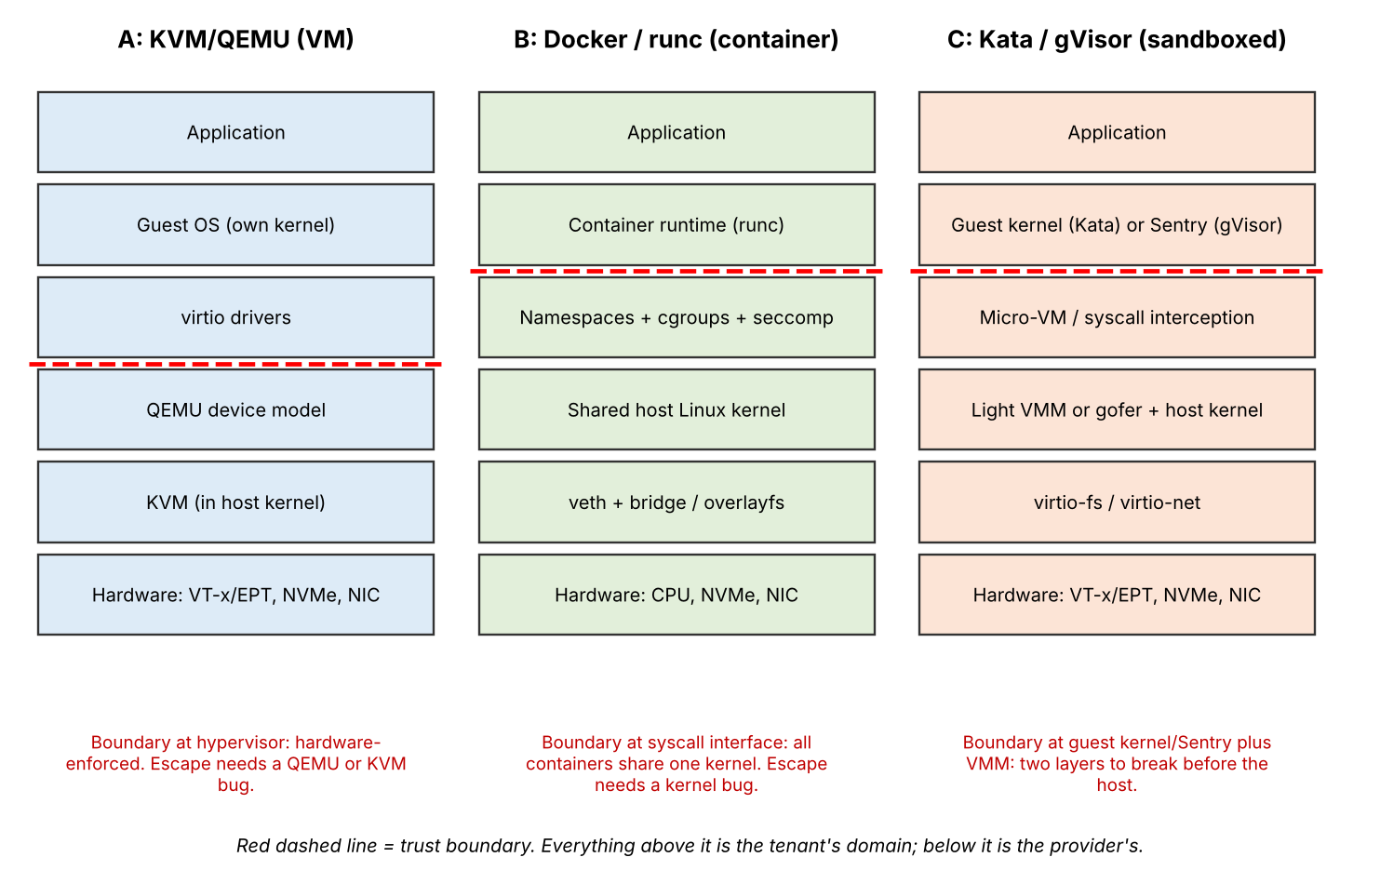
Figure . Layered architectures of the three suggested approaches with the trust boundary marked.
What to write for each approach
- Isolation enforcer. KVM: the CPU's hardware virtualization extensions (VT-x with EPT) enforced by the KVM module, with QEMU as the device model. Docker: Linux namespaces for visibility, cgroups for resource limits, and seccomp and capabilities for syscall filtering, all implemented by the one shared host kernel. Kata: each pod runs inside its own lightweight VM with its own guest kernel. gVisor: a user-space kernel (the Sentry) answers the application's syscalls so that few reach the host kernel.
- CPU. VMs run on vCPU threads scheduled by the host; privileged operations cause VM exits. Containers are ordinary host processes scheduled by CFS and limited by cgroup quotas or cpusets. Sandboxed runtimes add either a VM or syscall interception on top.
- Memory. VMs use extended page tables (guest-virtual to guest-physical to host-physical), with ballooning, KSM page sharing and swap as overcommit tools. Containers use cgroup memory limits and the host page cache directly. Kata adds a guest memory region per pod.
- Storage and network. VMs typically use virtio-blk and virtio-net, optionally with vhost for speed. Containers use overlayfs and a veth pair attached to a bridge. Kata uses virtio-fs or virtio-blk and a tap interface; gVisor uses a gofer process for file access and a user-space network stack.
- Relevance to EduCloud. Link each approach to a real workload: the SIS database needs strong isolation, the LMS web tier needs density and fast scale-out, and departmental research workloads are the least trusted and the most variable.

Task 2: Dominant overhead source
Name one dominant overhead per approach and, more importantly, explain it through the resource path: where in the stack it happens, why it limits performance for the workloads that matter, and how its frequency or cost changes as instances or I/O rate grow. A bare label such as "VM exits" will not score.
Approach | Likely dominant overhead | How it scales
KVM/QEMU | VM exits caused by I/O and interrupts, plus the two-dimensional EPT page walk on TLB misses | Exit rate rises with I/O rate; with overcommit, vCPUs wait for a core, so steal time rises with the ratio
Docker/runc | Contention on the shared kernel and the virtual network path (veth, bridge, iptables/conntrack) | Per-packet cost and lock contention rise with container count and packet rate; there is little per-instance hardware overhead
Kata | VM exits plus virtio-fs or virtio-net I/O path, together with the per-pod VM memory cost | Similar to KVM but with extra guest-to-host file-system hops
gVisor | System-call interception, since every syscall is handled by the Sentry instead of the native kernel | Overhead is proportional to the syscall rate, so syscall-heavy databases suffer most

Explain why this is the right overhead to analyse: for a registration-week web and database mix, the workload is dominated by many small I/O operations and network requests, so the cost per I/O operation (an exit, a bridge traversal or an intercepted syscall) multiplies by a very large count.
Turning the overhead into something you can model
The strongest answers express each overhead as a rate multiplied by a unit cost, because that form drops straight into the Task 3 equations. For the VM-based approaches the exit cost per second is the exit rate times 1.5 microseconds, and the exit rate is itself proportional to the I/O rate: if each network packet or disk request causes on average k exits, then exits per second equal k times the I/O operations per second. A VM serving 10,000 requests per second at k = 2 therefore spends 20,000 x 1.5 us = 3% of one core in exits, and a doubling of the request rate doubles that cost. For gVisor, the same structure applies with syscalls per second and the extra cost per intercepted syscall relative to the 0.2 microsecond native cost.
How the cost changes as co-location grows
Explain the scaling behaviour separately for the two ways it can grow. First, as the number of co-located instances increases, the cost per exit or per packet does not change by itself, but the contention around it does: more vCPUs compete for the same cores (steal time), more containers share one bridge and one connection-tracking table, and more guests compete for the same last-level cache and memory bandwidth. Second, as the I/O rate per instance rises, the count of expensive operations rises linearly, so the overhead fraction grows until the CPU or device saturates. Showing that you understand both effects, and which one dominates for your chosen workload, is what separates a justified answer from a list of mechanism names.
Finish this section with one sentence per approach that states the overhead and its trigger, for example: KVM is limited by exits per I/O, Docker by shared-kernel and bridge contention, and gVisor by syscalls per second. Those three sentences are what you will test directly in the experiments.

Task 3: Quantitative performance model
This is the heaviest-weighted task, so spend time here. Start with a symbols table, state every assumption with a reason, derive the four expressions below for each approach, and finish each with a worked number. The marker explicitly penalises quoting percentages from papers; the given parameters (1.5 µs per VM exit, 0.2 µs per native syscall, 25 Gbps, 8 GB per VM, 64 cores, 512 GB) are meant to be the inputs.
CPU capacity
With an overcommit ratio r (vCPUs per physical core), a vCPU can receive at most 1/r of a core. Overhead then reduces what it does with that share. If a VM generates n_exit exits per second, the fraction of time lost to exits is n_exit × 1.5 µs. Steal time s is the fraction of time a runnable vCPU waits for a core; model it as growing with r (for example s = 0 at r = 1, and a value you justify, or measure, at larger r).
C_eff(r) = (1/r) x (1 - n_exit x 1.5e-6) x (1 - s(r))
Worked example (assumptions are yours to state): at r = 4 with n_exit = 20,000 exits/s, overhead is 20,000 × 1.5 µs = 3%; take s(4) = 5%. Then C_eff = 0.25 × 0.97 × 0.95 ≈ 0.230 of a core per vCPU. For gVisor, replace the exit term with the syscall term: extra cost per syscall × syscall rate. If a syscall costs 2 µs instead of 0.2 µs and the workload makes 100,000 syscalls per second, the loss is 1.8 µs × 100,000 = 18%. For plain containers, the syscall is native (0.2 µs) so the dominant CPU loss is contention, not interception.
Memory
The number of instances that fit without ballooning, swapping or page sharing is bounded by RAM minus what the host keeps for itself, divided by demand plus per-instance overhead.
N_mem = floor( (M_host - M_reserve) / (M_vm + M_overhead) )
Worked example: with M_host = 512 GB, an assumed M_reserve = 32 GB for the host OS and caches, M_vm = 8 GB and M_overhead = 0.3 GB for QEMU and page tables, N_mem = floor(480 / 8.3) = 57 VMs. For containers with about 0.05 GB overhead, N_mem = floor(480 / 8.05) = 59. Sandboxed runtimes sit in between because each pod carries a guest kernel (assume 0.1 to 0.2 GB). Note the important consequence: with 2 vCPUs per VM and r = 4, the CPU limit is 64 × 4 / 2 = 128 VMs, so memory is the binding constraint at 57.
I/O and network
If N instances share a 25 Gbps NIC and each is saturating, the fair share is the usable line rate divided by N. The usable line rate is reduced by the efficiency of each path (for example vhost-net or veth and bridge processing, which you can measure with iperf3 on one instance).
T_inst(N) = min( R_line x eta_path / N , R_cpu_limit )
Worked example: with eta = 0.92 and N = 8, T = 25 × 0.92 / 8 ≈ 2.9 Gbps per instance. The second term in min() reminds you that at high rates the per-packet CPU cost, not the wire, may be the bottleneck; that is where the approaches differ. Do the same for disk using the NVMe IOPS or bandwidth you measure with fio.
Density against a service-level target
Combine the limits and then check the target. Define degradation D(N) as the fractional drop in a chosen metric (throughput or request latency) relative to bare metal, using your CPU, memory and I/O terms. The largest allowable density is the minimum of the three limits, reduced until D(N) ≤ 10%. Figure 3 summarises the logic.
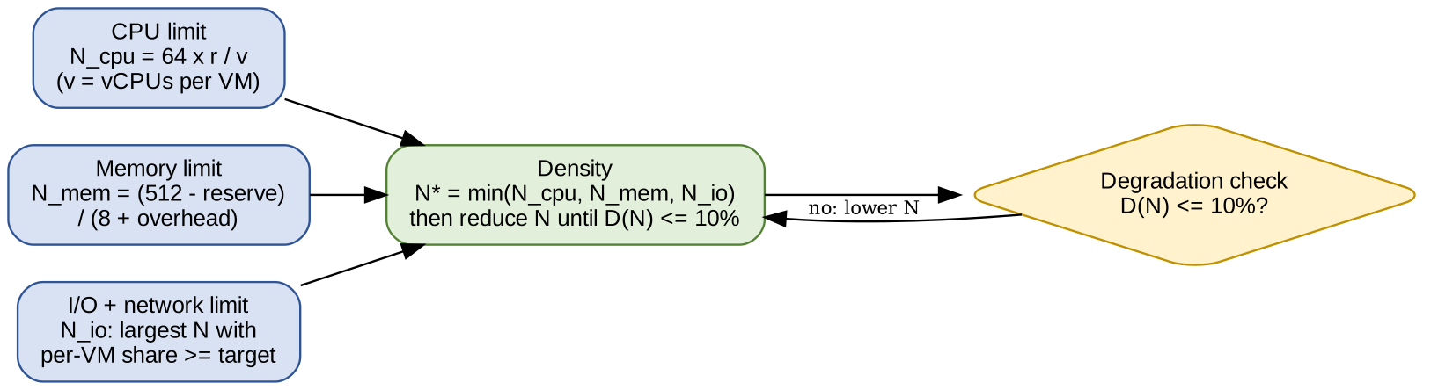
Figure . How the CPU, memory and I/O limits combine into the density you can promise.

Task 4 : Behaviour under different operating conditions
A table of numbers alone is rejected, so each case needs a mechanism-level explanation: what happens inside the virtualization layer, why overhead changes, and what that does to latency and throughput. Tie each paragraph back to a term in your Task 3 model.
- Best case. Few instances, CPU-bound work with vCPUs pinned and hugepages enabled, and low overcommit. Exits are rare, EPT walks hit in the TLB, and the virtualization cost approaches zero. For containers the best case is similar to bare metal. For gVisor the best case is a workload that makes few syscalls.
- Typical case. Registration week brings many short web requests and database queries. The virtual I/O path is exercised continuously, so exit rates, bridge traversals and syscall counts matter. Latency rises more than throughput because queuing adds to per-operation cost.
- Worst case. Examples: a noisy neighbour exhausting cache and memory bandwidth or CPU; memory overcommit causing swapping, where each guest page fault becomes a disk access and tail latency explodes; live migration, where repeated copying of dirty pages consumes network and CPU during peak load; and I/O storms saturating the shared queue. Explain which approach suffers most and why, for example that containers share one kernel scheduler and I/O queue, so interference crosses container boundaries more easily.
Using the model to explain the numbers
Back each case with a short calculation. For queuing delay, a simple single-server approximation is enough: if a vCPU or device has service time S and utilisation rho, the mean response time is about S / (1 - rho). At rho = 0.5 the delay is twice the service time, but at rho = 0.9 it is ten times, which is why latency rises much faster than throughput falls as overcommit grows. Apply it to the effective capacity from Task 3: raising the overcommit ratio from 2:1 to 8:1 lowers the capacity each vCPU receives, which pushes utilisation of that share toward 1 and makes the tail (95th percentile) latency explode.
Then compare approaches in the worst case. Under a noisy neighbour, a VM is protected from CPU theft by its own scheduler share, but it still suffers from shared cache and memory bandwidth. A container is exposed to the same hardware contention and additionally shares kernel locks, the block-layer queue and the network stack, so interference passes between containers more easily unless cgroup limits are set on CPU, memory and I/O. In a sandboxed runtime the guest or Sentry adds a buffer against kernel-level interference, but the extra layer costs more per operation. During live migration of a VM, dirty pages are copied repeatedly, so a write-heavy guest keeps re-dirtying memory and the migration consumes network bandwidth and CPU for longer; containers are usually restarted rather than migrated, which changes the nature of the disruption rather than removing it.

Task 5 : Security threat and vulnerability analysis
Build a threat model per approach, not a generic list. Begin with the attack surface of each architecture (hypervisor and device emulation, shared kernel, management plane, images and snapshots, virtual network), then analyse at least four threat categories. For each threat say which approach is more or less exposed, referring to the trust boundary in Figure 2, and link it to confidentiality, integrity and availability of student records.
Threat | KVM/QEMU | Docker/runc | Kata / gVisor
VM or container escape | Needs a hypervisor or QEMU device-emulation bug; smaller interface but high impact | Needs a kernel or runtime bug; the whole kernel syscall surface is exposed | Must break guest kernel or Sentry and then the VMM; narrowest effective surface
Cross-tenant side channels | Exposed through shared caches and SMT siblings | Exposed equally, plus shared kernel state | Similar to KVM for Kata; gVisor reduces kernel exposure but not hardware sharing
Unpatched guests and sprawl | Each guest kernel needs patching, so audit finding is serious | One host kernel to patch, but stale images persist | Patch guest kernel image and host
Image tampering | Copied disk images are a real risk | Layered registry images, easier to sign and scan | Same as container, plus guest kernel image
Insecure live migration | Memory contents travel the network unless encrypted | Checkpoint/restore is rarely used in production | Depends on VMM support
Virtual-network spoofing | Software switch; needs segmentation | Bridge and iptables; flat network by default | Per-pod interface; segmentation possible

Rate each cell yourself (for example low/medium/high) and justify it in a sentence; the ratings above are starting points that you should check against your own reading and lab results.

Task 6 : Isolation-performance trade-off
Turn your Task 3 and Task 5 findings into a formal decision problem. The formulation must be yours, so use the symbols and numbers you derived rather than a generic template.
- Decision variables: the approach a for each workload class, instances per host n, whether the host is dedicated or shared, and SMT on or off.
- Objective: for example minimise the number of hosts H needed to carry all instances, or minimise a weighted cost of hosts plus residual risk.
- Constraints: degradation D_a(n) ≤ 10%, an isolation level for SIS at least equal to a threshold you define from Task 5, the memory and CPU limits from Task 3, and H ≤ 16.
min H = sum over classes t of ceil( N_t / n_t )
s.t. D_a(n_t) <= 0.10; Iso(a, mitigations) >= Iso_SIS; n_t <= min(N_cpu, N_mem, N_io); H <= 16
If you prefer a single score, define cost = w1 × hosts + w2 × risk, with the risk term built from your threat ratings. Explain how you chose the weights.
A worked illustration
To show that the formulation follows from your analysis, instantiate it with your own numbers. Suppose the SIS and its database need 60 VMs, the LMS and exam portal need 120 instances, and departmental research needs 100 more. Using the memory limit from Task 3 (about 57 VMs per host), SIS alone needs ceil(60 / 57) = 2 dedicated hosts if SMT is on. If your Task 7 analysis says SIS needs SMT off, the CPU limit halves, and you must recompute whether memory or CPU now binds. Repeat for the other classes with the approach that satisfies each class's isolation requirement, then add up the hosts and compare with the 16 available. This turns an abstract optimisation into a concrete answer you can defend.
How to solve it
The search space is small (a few approaches, a few densities, SMT on or off, dedicated or shared), so you can enumerate every combination in a spreadsheet or a short Python script, discard those that violate a constraint, and rank the rest by cost. Finish with a brief sensitivity check: change the degradation limit from 10% to 5% or double the weight on risk, and report whether the best choice changes. A decision that stays the same under reasonable changes is easier to defend than one that flips.

Task 7 : Evaluate mitigations
Select at least three mitigations from your Task 5 findings, for example disabling SMT, dedicated hosts for sensitive tenants, a sandboxed runtime, image signing and micro-segmentation. For each, give four things: why it fits the threat, the residual risk, a cost estimated with your Task 3 model, and a verdict on whether it is acceptable for the SIS.
Mitigation | Threat addressed | Model-based cost (example) | Residual risk
SMT off | Cross-thread side channels | Logical CPUs halve (128 to 64 per host), so N_cpu falls by about half; recompute D(n) | Cross-core and cache-level attacks remain
Dedicated hosts for SIS | Tenant co-residency and noisy neighbours | Fewer shared hosts, lower consolidation; compute extra hosts from the Task 6 model | Management-plane and storage attacks remain
Sandboxed runtime (Kata/gVisor) | Container escape, kernel bugs | Higher per-instance memory and syscall or exit overhead from your Task 3 terms | Hypervisor or Sentry bugs
Image signing | Image tampering and sprawl | Negligible runtime cost; adds pipeline steps | Compromised signing keys
Evaluating each mitigation
For every mitigation, write a short paragraph with the same four parts so the marker can find them. As an example, consider disabling SMT. It is applicable because many cross-VM side channels rely on two threads from different tenants sharing one physical core. The residual risk is that attacks through the shared last-level cache or memory bus still work across cores. The cost follows from the Task 3 model: with 64 cores and SMT on the host exposes 128 logical CPUs, and with SMT off only 64, so at a 4:1 overcommit the vCPU capacity falls from 512 to 256. If your SIS needs fewer vCPUs than that, the cost is acceptable on a dedicated SIS host even though it would be wasteful across the whole cluster.
Use a different cost mechanism for each mitigation so that your estimates are not all the same calculation. A sandboxed runtime changes the per-instance memory overhead and the exit or syscall term. Dedicated hosts change the number of hosts H in the Task 6 formulation. Image signing and micro-segmentation add almost no runtime cost but add operational work, which you can describe qualitatively and then confirm in the lab by checking that an unsigned image is refused or that traffic between two segments is blocked.
Close the section with a verdict for the SIS: which mitigations you would require, which you would treat as optional, and why. The marker is looking for a conclusion that balances protection of student records against the capacity you give up, not a claim that every mitigation is worth its cost.

Task 8 : Implement and test
Build a small reproducible laboratory. Use identical CPU, memory and disk limits and identical workloads for all approaches, and repeat each measurement at least five times so you can report mean and standard deviation. Nested virtualization on a laptop is allowed if you document it, and you should scale down the instance counts and say so if the hardware cannot support sixteen instances. The test setup must correspond to the Task 3 model, so use the same vCPU, memory and I/O settings as in your equations.
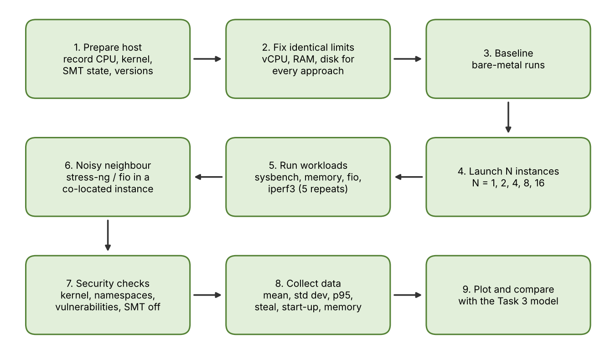
Figure 4. Experimental workflow from host preparation to comparison with the model.
- Workloads: sysbench cpu (or stress-ng) for CPU, sysbench memory or stress-ng for memory, fio for disk, iperf3 for network.
- Noisy neighbour: start a stress-ng or fio instance next to a victim running a fixed benchmark and compare victim latency with and without it, for each approach.
- Security validation: compare uname -r inside a container with the host (shared kernel), inspect /proc/self/ns and cgroup files, read /sys/devices/system/cpu/vulnerabilities, and test a mitigation such as SMT off or a Kata runtime.
- Reproducibility: keep scripts, configuration files and exact commands in one folder, and describe software versions and hardware in a short README so that another person could repeat your experiment.
Example commands to adapt
The commands below show the style of test you need. Adjust the limits to match your Task 3 parameters and keep them identical across approaches.
# CPU: 60 s run on 2 threads
sysbench cpu --threads=2 --time=60 run
# Memory bandwidth
sysbench memory --threads=2 --memory-total-size=20G run
# Disk: random 4k read/write with latency percentiles
fio --name=rw --rw=randrw --bs=4k --iodepth=16 --runtime=60 --time_based --direct=1 --size=2G
# Network: server in one instance, client in another
iperf3 -s and iperf3 -c <server> -t 30 -P 4
# Noisy neighbour in a co-located instance
stress-ng --cpu 2 --vm 1 --vm-bytes 2G --timeout 120s
# Security checks
uname -r; ls -l /proc/self/ns; grep . /sys/devices/system/cpu/vulnerabilities/*

Choosing and justifying test cases
Each test should map to a term in your model. The CPU test checks the effective-capacity equation, the memory test checks the memory-limit and page-walk assumptions, fio checks the disk path (virtio versus overlayfs versus gofer), and iperf3 checks the network efficiency eta you assumed. The noisy-neighbour test checks your worst-case analysis from Task 4. Write one sentence for each test saying which prediction it is intended to confirm or challenge; this is what the marker means by justified test cases.

Task 9 : Record experimental performance
Task 9 is about the quality and clarity of your data. Collect throughput, mean and 95th percentile latency, CPU steal time, context switches and, for the VM-based approaches, VM exits (for example with perf kvm stat on the host). Also record the start-up time and memory footprint of each instance, the degradation relative to the bare-metal baseline, and the results with and without at least one security mitigation such as SMT off or a sandboxed runtime.
Statistics and presentation
Repeat every configuration at least five times and report the mean plus or minus the standard deviation, with the number of repetitions stated. Discard a warm-up run if it is clearly different, and say so. Calculate degradation as (baseline - measured) / baseline for throughput, and (measured - baseline) / baseline for latency. Present at least one table that lets a reader compare approaches at a glance, and at least two graphs. Good choices are throughput against number of instances (one line per approach, with error bars) and 95th percentile latency with and without the noisy neighbour.
Keep the raw output files and the script that turned them into the graphs, so that every number in the report can be traced back. If a result looks odd, investigate rather than hide it: an unexpected value is often the most useful material for Task 10.

Task 10 : Compare theory with experiment
Do not repeat tables. Plot predicted and measured degradation together, compute the percentage error, and explain the gaps. Plausible causes include cache effects, scheduler behaviour, nested virtualization, laptop thermal limits and I/O paths you did not model. State which approach scaled best as instances grew, and say whether any measurement changes your Task 5 conclusions. For example, if gVisor's measured cost is far higher than your syscall model predicted, say why and what that does to your recommendation.
A structure that works
- Step 1: for each approach, put predicted and measured degradation for the same instance counts on one graph or in one table.
- Step 2: compute the error for each point, as (measured - predicted) / predicted, and summarise it (for example the average absolute percentage error).
- Step 3: say whether the trend matches (for example both rise roughly linearly with instances, or measured degradation bends upward earlier than predicted), separate from whether the absolute numbers match.
- Step 4: for each large gap, propose a cause and, where possible, test it. Examples: nested virtualization multiplies exit cost, so your measured KVM overhead on a laptop may be much larger than 1.5 us per exit would suggest; thermal throttling lowers throughput at higher instance counts; and the host page cache can make container disk results look faster than the model predicts.
- Step 5: say which approach scaled best (smallest growth of degradation as instances increase) and whether this agrees with your Task 4 expectation.
Finally, revisit your Task 5 threat model. If a measurement changes a security conclusion, say so: for example, if a sandboxed runtime proves too slow for database traffic, then its protective value must be weighed against performance more carefully, and a dedicated-host VM may become the better answer for the SIS.

Task 11 : Recommend and defend
A hybrid is usually the most defensible answer because EduCloud has different workloads with different needs. One option is KVM VMs on dedicated hosts for the SIS and its database (strong isolation, acceptable cost), containers for the stateless LMS web tier (high density, quick scaling), and a sandboxed runtime for the least trusted workloads. Support your choice with your modelled and measured numbers, the operational costs (patching, image management, migration and monitoring), the limitations, and a short argument about growth from 400 to several thousand instances (for example orchestration, a signed image registry and automated patch pipelines).
Comparison table
A short comparison table makes it easy for the marker to see that the recommendation is balanced. Fill the cells with your own results rather than with the generic descriptions below.
Criterion | KVM/QEMU (VM) | Docker (container) | Kata / gVisor
Modelled density | Memory-limited, lower | Highest | Between the two
Measured overhead | From your Task 9 data | From your Task 9 data | From your Task 9 data
Isolation strength | Strong (hardware boundary) | Weaker (shared kernel) | Strong to medium
Patching effort | Every guest kernel plus host | Host kernel plus images | Host, guest kernel and runtime
Migration | Live migration supported | Restart or reschedule | Limited, depends on runtime

Operations and growth
Discuss the day-to-day cost of running your design. For patching, say who patches guest kernels in a VM design (the audit found outdated kernels) and how containers change this, since a single patched host kernel and rebuilt images fix many instances at once. For image management, describe a signed registry with scanning and a rule that images are not copied by hand, which closes the audit finding. For monitoring, name what you would watch (steal time, exit rate, p95 latency, network drops). When you consider growth from 400 to several thousand instances, note what scales well (container orchestration, automated image pipelines) and what does not (manual VM patching, per-VM configuration), and say how many hosts your Task 6 model would need at the larger size.
End with the limitations of your own study, such as the small test scale, laptop hardware or nested virtualization, and say how they affect how much confidence the reader should place in the numbers.

Task 12 : Re-evaluate for external tenants
The changed requirement is a stress test of your own design. Answer the four parts in order and refer back to specific earlier results.
- A. Impact (2). Which assumptions break: tenants are no longer trusted; jobs are long, I/O- and network-heavy batch work; registration peak is three times normal; live migration is used for patching; and regulation demands demonstrable isolation of student records. Explain how mixing batch and latency-sensitive work changes the performance picture (shared NIC, storage queues, cache) and the threat model (external attackers, co-residency, migration traffic).
- B. Evaluate the original design (2). Rerun your Task 3 model with the new I/O profile and 3× load and test whether the 10% target still holds. Judge whether your isolation level is adequate against less-trusted tenants, and consider whether another architecture would do better.
- C. Adapt or redesign (2). Decide to retain, modify or redesign, and describe what changes and what it does to density, throughput and attack surface. Figure 5 gives one possible placement logic.
- D. Defend (2). Use your model, noisy-neighbour results, mitigation experiments and cost trade-offs so that the decision follows logically from the evidence.
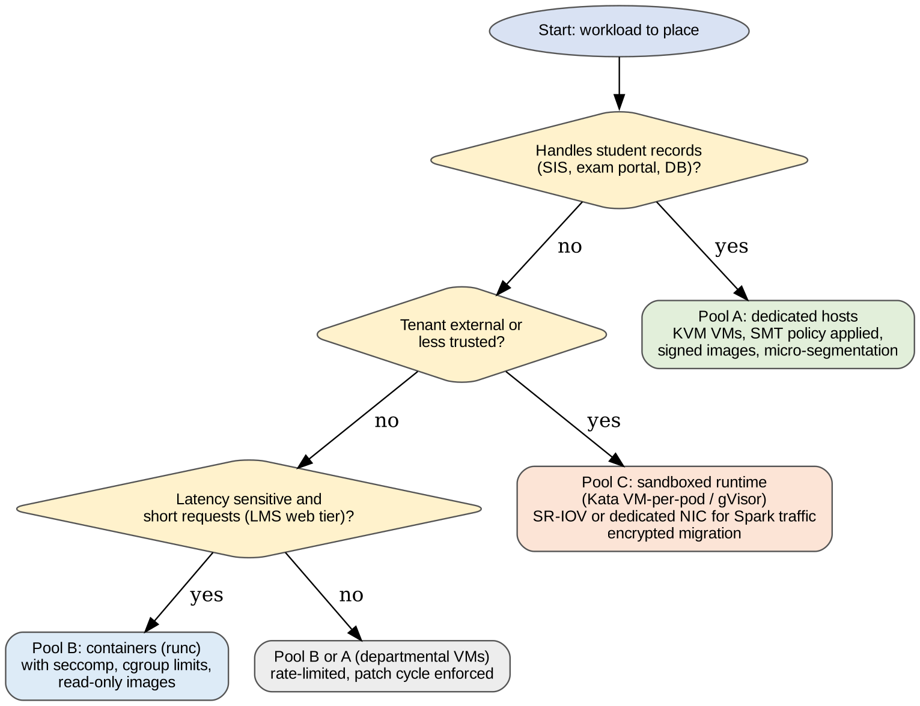
Figure 5. One possible placement policy for the redesign: separate host pools by data sensitivity and trust level.
A typical modify-not-replace answer keeps the SIS design, adds separate host pools for external tenants, runs their Spark jobs under a stronger isolation layer, gives data-intensive jobs dedicated or SR-IOV NICs, and encrypts migration traffic. State the cost in hosts and density so the trade-off is visible.

4. Common ways to lose marks
- Quoting overhead percentages from papers instead of deriving them from the given 1.5 µs and 0.2 µs values.
- Counting two configurations of one hypervisor as different approaches.
- Presenting tables with no explanation of what happens inside the virtualization layer.
- Running experiments with different resource limits per approach, or with only one repetition.
- Recommending the most secure or the fastest option without balancing both.
- Treating Task 12 as a fresh essay instead of re-using your model and measured results.

5. Final checklist
- Three distinct approaches with labelled diagrams and trust boundaries
- Symbols table, assumptions and worked numbers for CPU, memory, I/O and density
- Condition analysis explained by mechanisms, not just numbers
- Threat matrix with at least four threat categories and CIA impact
- Trade-off formulation using your own numbers
- At least three mitigations with residual risk and model-based cost
- Reproducible lab description, a noisy-neighbour experiment and one security check
- At least one table and two graphs with mean ± standard deviation
- Predicted versus measured error analysis
- Recommendation covering performance, security, operations and growth
- Task 12 parts A to D, each citing earlier results

